



INTERNSHIP PROJECT

**Thenmozhi R**

**BY**

PAYTM EPURCHASE DATA ANALYSIS USING SQL

LOADING THE DATA

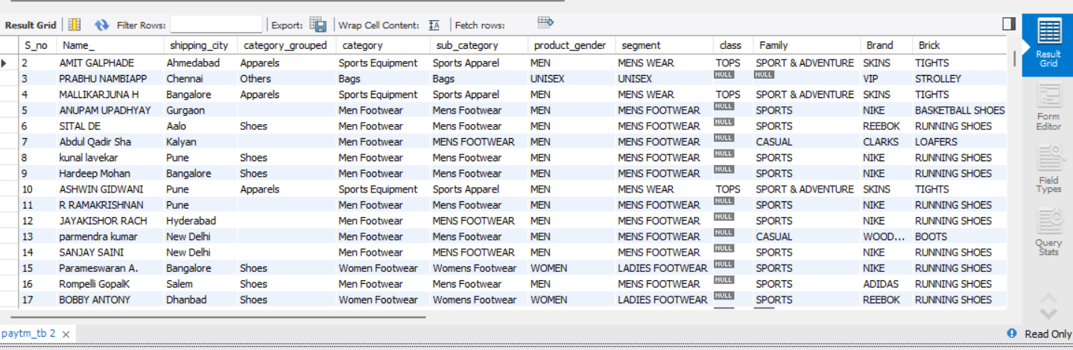

1. What does the "Category_Grouped" column represent, and how many unique categories are there?

select distinct(category_grouped)as unique_categories,count(*)as no_of_unique_categories

from paytm_tb

group by category_grouped

order by unique_categories;

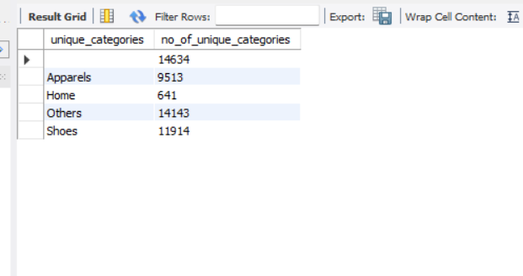

2. Can you list the top 5 shipping cities in terms of the number of orders?

SELECT Shipping_city ,COUNT(Shipping_city) as Total_Orders

FROM paytm_tb

GROUP BY Shipping_city

ORDER BY Total_Orders desc

LIMIT 5 ;

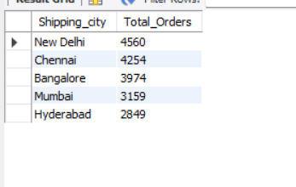

3. Show me a table with all the data for products that belong to the "Electronics" category.

SELECT * FROM paytm_tb

WHERE Category = "Electronics";

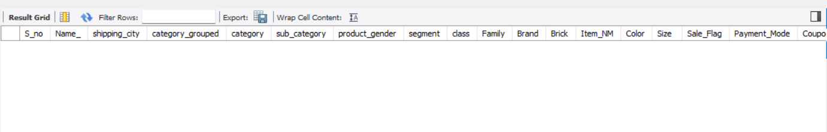

4. Filter the data to show only rows with a "Sale_Flag" of 'Yes'.

SELECT * FROM paytm_tb

WHERE Sale_Flag LIKE "Sale" ;

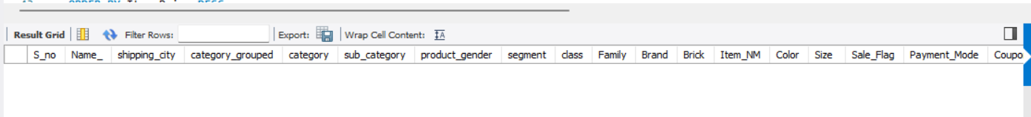

5. Sort the data by "Item_Price" in descending order. What is the most expensive item?

SELECT Item_NM , Item_Prize

FROM paytm_tb

ORDER BY Item_Prize DESC

LIMIT 1 ;

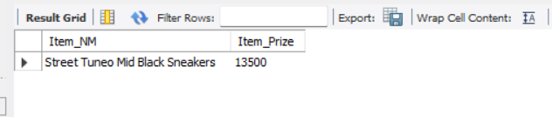

6. Apply conditional formatting to highlight all products with a "Special_Price_effective" value below $50 in red.

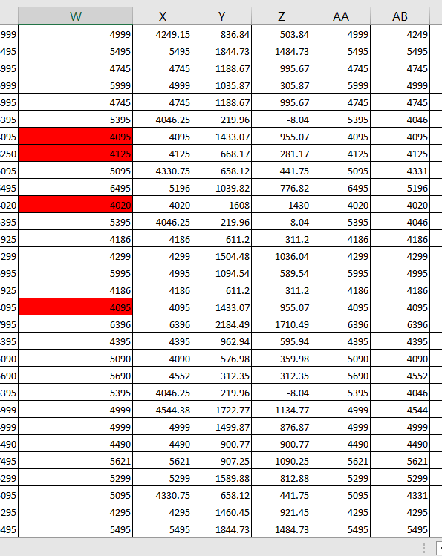

7. Create a pivot table to find the total sales value for each category.

SELECT Category , SUM(Item_Prize) as Total_Sales_Value

FROM paytm_tb

Group by Category ;

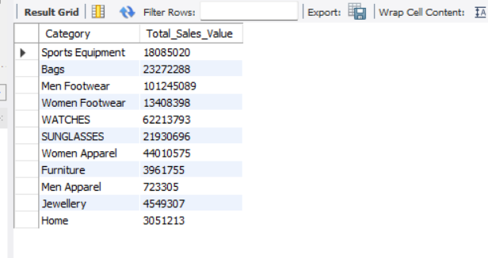

8. Create a bar chart to visualize the total sales for each category

SELECT Category , SUM(Item_Prize) as Total_Sales

FROM paytm_tb

Group by Category

ORDER BY Total_Sales;

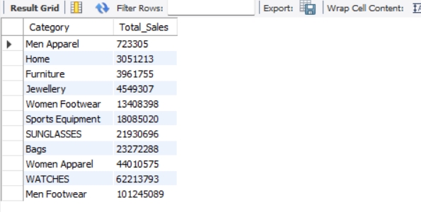

9. Create a pie chart to show the distribution of products in the "Family" category.

SELECT Family ,COUNT(Family)asTotal_Products_in_Family

FROM paytm_tb

Group by Family ;

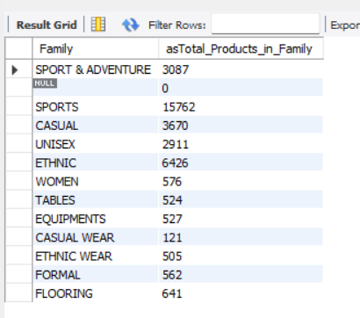

10. Ensure that the "Payment_Method" column only contains valid payment methods (e.g., Visa, MasterCard)

select *

from paytm_tb

where Payment_Mode in ("COD","Prepaid");

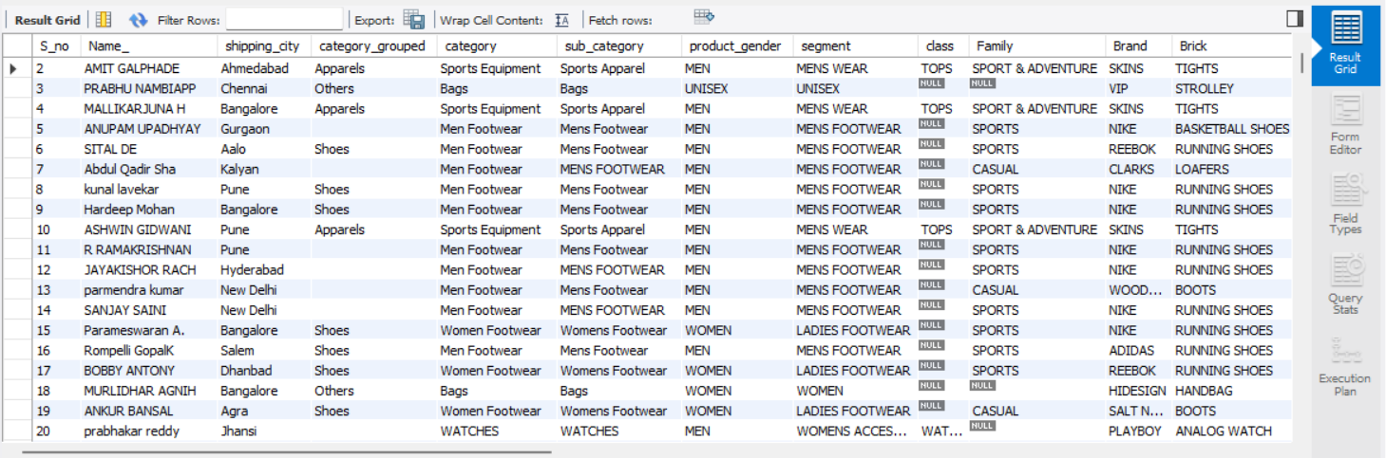

11. Calculate the average "Quantity" sold for products in the "Clothing" category, grouped by "Product_Gender."

SELECT Product_Gender , AVG(Quantity) as Total_Quantity_Sold

FROM paytm_tb

WHERE Category_Grouped ="Apparels"

GROUP BY Product_Gender;

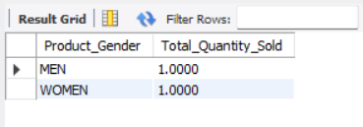

12. Find the top 5 products with the highest "Value_CM1" and "Value_CM2" ratios. Create a chart to visualize this data.

SELECT *, ROUND((Value_CM1/Value_CM2),2) AS Ration

FROM paytm_tb

ORDER BY Ration DESC

LIMIT 5 ;

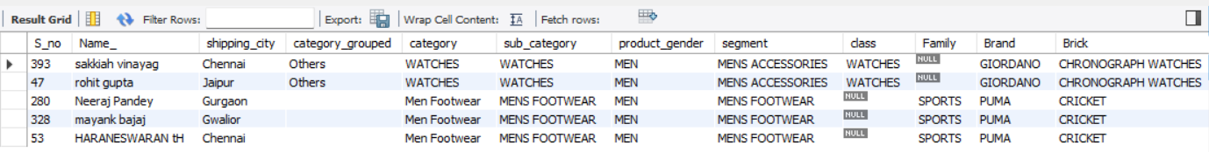

13. Identify the top 3 "Class" categories with the highest total sales. Create a stacked bar chart to represent this data.

SELECT Class, SUM(Item_Prize) AS Total_Sales

FROM paytm_tb

Group by Class

Order by Total_Sales DESC

LIMIT 3 ;

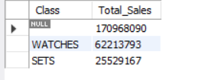

14. Use VLOOKUP or INDEX-MATCH to retrieve the "Color" of a product with a specific "Item_NM."

select Color

from paytm_tb

where Item_NM ="your specific Item_NM";



15. Calculate the total "coupon_money_effective" and "Coupon_Percentage" for products in the "Electronics" category.

SELECT Category , SUM(coupon_money_effective) AS Total_Coupon_Money ,SUM(Coupon_Percentage) AS

Total_Coupon_Percentage

FROM paytm_tb

WHERE Category = "Electronics" ;

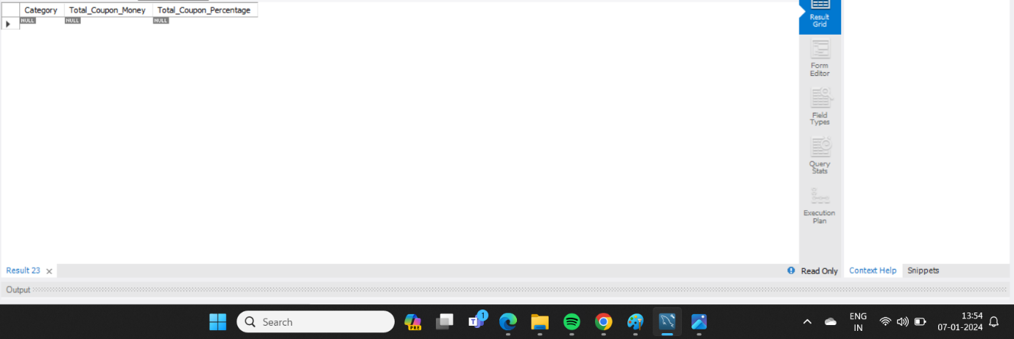

16. Perform a time series analysis to identify the month with the highest total sales.

select extract(Month from Sale_Flag) as Month,

extract(Year from Sale_Flag) as Year , Sum(Paid_pr) as Total_Sales

from paytm_tb

group by Month,Year

order by Total_Sales desc

limit 1;

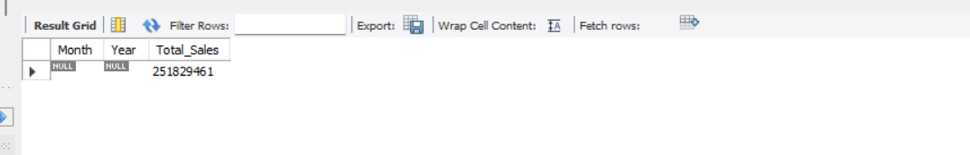

17. Calculate the total sales for each "Segment" and create a scatter plot to visualize the relationship between "Item_Price" and "Quantity" in this data.

SELECT Segment , SUM(Item_Prize) AS Total_Sales

FROM paytm_tb

GROUP BY Segment;

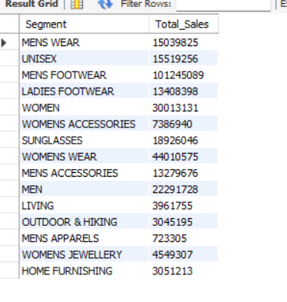

18. Use the AVERAGEIFS function to find the average "Item_Price" for products that have a "Sale_Flag" of 'Yes.'

SELECT Item_NM,AVG(Item_Prize)

FROM paytm_tb

WHERE Sale_Flag="ON Sale"

Group by Item_NM ;

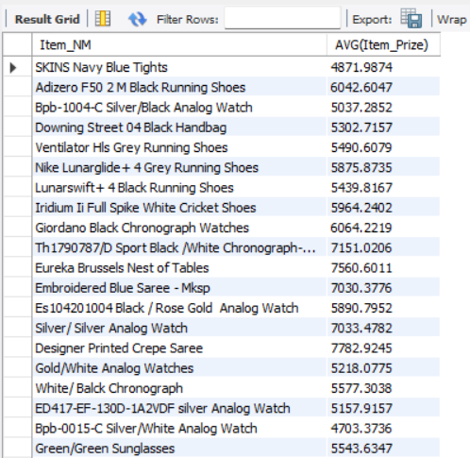

19. Identify products with a "Paid_pr" higher than the average in their respective "Family" and "Brand" groups.

select Family , Brand , Item_NM,Paid_pr

from paytm_tb

where paid_pr >( select avg(paid_pr)

from paytm_tb)

group by Family,Brand , Item_NM,Paid_pr

order by Paid_pr desc ;

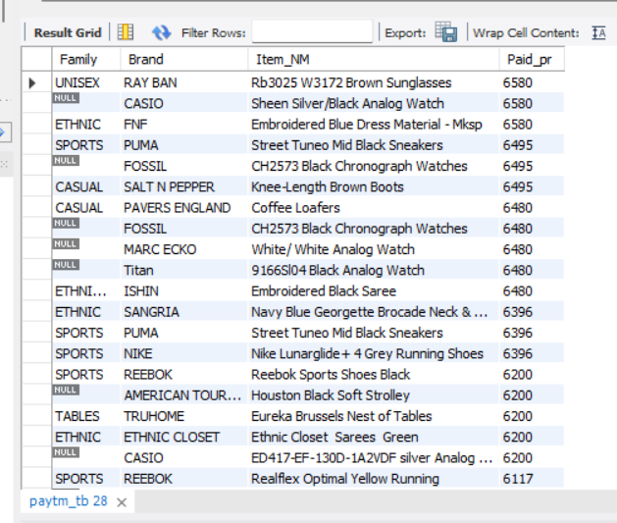

20. Create a pivot table to show the total sales for each "Color" within the "Clothing" category and use conditional formatting to highlight the highest sales.

SELECT DISTINCT Color ,SUM(Item_Prize) AS Total_Sales

FROM paytm_tb

WHERE Category_Grouped = "Apparels"

GROUP BY Color ;

